

2x³ + 2x² + C

2\*1³ + 2\*1² + C = 3

C = -1

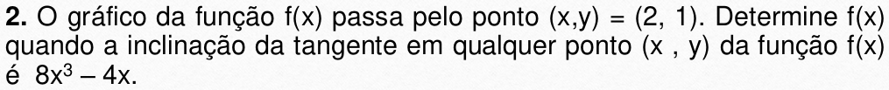

$\frac{dy}{dx}=8x³−4x$

2x⁴ -2x² + C

2 \* 2⁴ – 2 \* 2² + C = 1

C = -23





$\frac{1}{x³}dx+2xdx$

$\frac{1}{2x²}+2\frac{x²}{2}$

$\frac{−1+2x⁴}{2x²}+C$

$\frac{−1+2∗3⁴}{2∗3²}+C=0$

$C=\frac{−161}{18}$

$10x\frac{³}{²}dx+3xdx$

$4x²\sqrt{x}+\frac{3x²}{2}+C$

$4∗1²\sqrt{1}+\frac{3∗1²}{2}+C=3$

C = $\frac{5}{2}$



$\frac{dy}{dx}$ = 2x⁵ + 2x³ + 2

$\frac{x⁶}{x⁴}+\frac{x⁴}{2}+2x+C$

$\frac{2⁶}{2⁴}+\frac{2⁴}{2}+2∗2+C=1$

C =-15